Creating Secured REST APIs
Vlad Fintina
Group 258-1

Creating Secured REST APIs
A Representational State Transfer (REST) Application Programming Interface (API) allows different systems to communicate and exchange data over the internet. REST APIs typically use JSON (JavaScript Object Notation) as the data format and standard HTTP methods such as:
- GET – Retrieve data
- POST – Create new resources
- PUT – Update existing resources
- DELETE – Remove resources
By using these standardized verbs and status codes, REST APIs provide a uniform interface across diverse applications, supporting multiple content types.
Stateless Communication
REST APIs are designed to be stateless, meaning the server does not store any information about current client sessions or connections. All the necessary information for each request must be included by the client.
In your application, the REST API handles:
- Access control – Ensuring only authenticated clients can access protected resources
- Resource manipulation – CRUD operations on data such as matches, tickets, or invoices
- Session management – Implemented in a stateless manner through tokens
Securing REST APIs
Because REST APIs control the flow of sensitive data between applications, they are frequent targets for attacks. One key way to protect them is through access control, which ensures that only authorized clients can use the API.
Access control involves two main mechanisms:
- Authentication – Verifying that the client is who it claims to be
- Authorization – Ensuring the client has permission to perform the requested action
Using JSON Web Tokens (JWTs)
A common approach for securing REST APIs is by using JSON Web Tokens (JWTs). JWTs are digitally signed JSON objects that can be verified and trusted. They enable:
- Authentication
  - The server signs the token using a private key
  - The client can be verified using the corresponding public key
  - Confirms the identity of the client
- Authorization
  - After a successful login, the server issues a JWT access token
  - The client includes this token in every subsequent request
  - The server validates the token to determine what actions the client is allowed to perform
This approach ensures that the REST API remains secure, stateless, and scalable, while protecting sensitive data from unauthorized access.
Implementing secured REST APIs in an app:
In this example, we will implement a simple secured REST API using two services:
- Authentication Service – Responsible for generating JSON Web Tokens (JWTs) for authenticated users.
- Example Service (service1) – Verifies the JWT before responding to any client requests.
This demonstrates how authentication and authorization can be handled in a microservices architecture.
Step 1: Authentication Service
The authentication service exposes a POST endpoint for logging in and generating a JWT:
- Endpoint URL: /auth/login
- Request: User credentials in JSON format (e.g., username and password)
- Response: JWT token if authentication succeeds, or an error message if it fails
Logic
- Receive a POST request at /auth/login.
- Verify the credentials against a hardcoded user (for demonstration purposes).
  - Example: username = "admin", password = "admin"
- If credentials are correct:
  - Generate a JWT token using jwt.sign().
  - Return the token as a JSON object.
- If credentials are incorrect:
  - Return an error message indicating authentication failed.
- If an error occurs while creating the token:
  - Return a server error response.
Our function should look like this:
app.post('/auth/login', async (req, res) => {
const { email, password } = req.body;
try {
if (email === 'admin' && password === 'admin') {
const token = jwt.sign({ id: 'user._id' }, process.env.JWT_KEY, { expiresIn: '1h' });
res.json({ message: 'Login successful', token });
} else return res.status(401).json({ message: 'Invalid credentials' });
} catch (err) {
console.error(err);
res.status(500).json({ message: 'Server error' });
}
});

The jwt.sign function needs a key, which should not be exposed in the code. For that, we created an .env file in which we added the environment variable for our key.
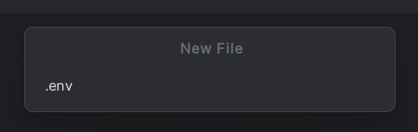
Content of .env file:
JWT_KEY="your_jwt_secret"

Note that you will need to import some things in your app in order to use jwt:
const express = require('express')
const jwt = require('jsonwebtoken');

Step 2: Using the Token in Another Service (service)
To demonstrate how the generated JWT is used, we created a second service called service1. This service exposes a protected endpoint that verifies whether a user is authenticated before allowing access.
- Endpoint URL: /authorization
- Method: POST
- Requirement: A JWT token must be included in the request body
Request Flow
- The client sends a POST request to /authorization.
- The request body must contain a JSON field named token.
- The service extracts the token from the request body.
- The token is verified using jwt.verify() and the secret key stored in the environment variable JWT_KEY.
Response Logic
- If the token is valid:
The service confirms that the user is authenticated and returns a success message.
- If the token is invalid or expired:
The verification fails, an error is caught, and the service responds with an authentication error.

app.post('/authorization', async (req, res) => {
const { token } = req.body;
try{
const verifToken = jwt.verify(token, process.env.JWT_KEY)
if (verifToken) {
res.status(200).json({ message: 'Authenticated user accessed service' });
}
} catch(err) {
console.error(err);
res.status(401).json({ message: 'User not authenticated' });
}
});

Our example app uses docker for deploying the solution, so some of the code such as the environment variables import is found in the docker-compose.yml file.

To check the REST APIs, we will use Postman. Here are two example requests for checking these APIs:
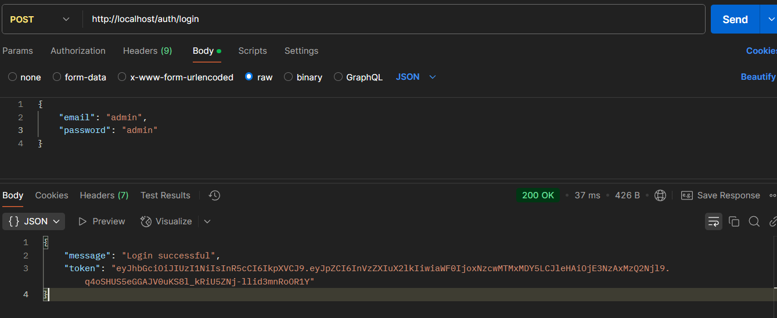
Use the previously generated token in the body of the second request:
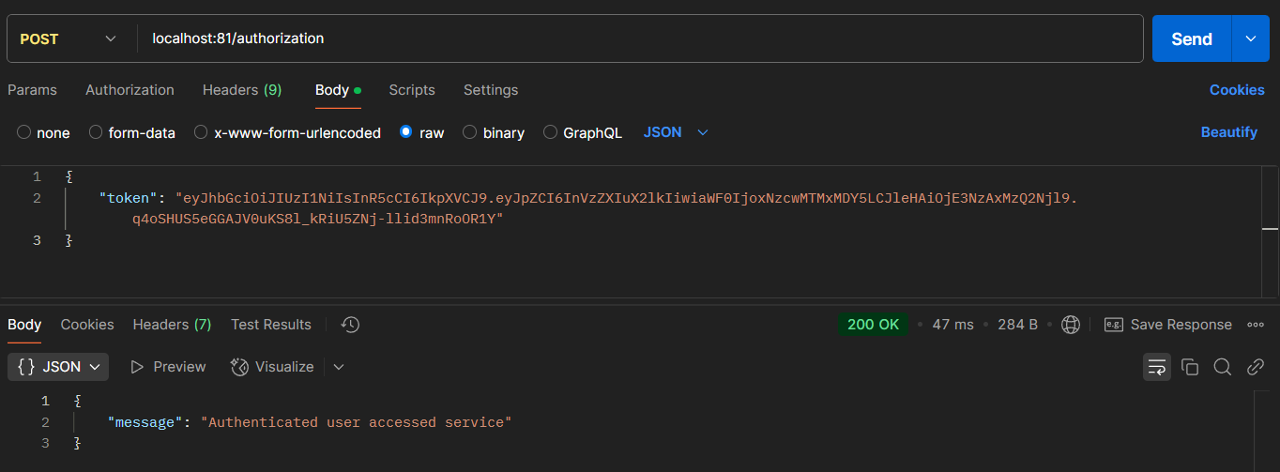
For the working example app, reference this git project:

